08th September 2016

Hot August for YOKOHAMA Motorsports in Italy

The very hot summer month in Italy did not put off a very successful string of motorsport results in hill-climbing and rally races for drivers on YOKOHAMA tyres.

In the past weekends, YOKOHAMA has been involved in very significant Italian races obtaining splendid results. Following the success on the Trento-Bondone and the Svolte di Popoli races, YOKOHAMA and Luca Gaetani kept their close partnership for the 51st Trofeo Fagioli held in Gubbio on the 20th and 21st August and included within the Italian Turismo Championship.

The Italian Champion raced with his Ferrari 458 Challenge EVO of Ram built by Vimotorsport and equipped with YOKOHAMA ADVAN A005 slick tyres in the 260/660 R19 on the front and 310/690 R19 on the back, achieving a new success in the GT Cup class.

At the end of the race, Gaetani expressed his choice of YOKOHAMA’s medium compound for the trials and opted to go with a soft compound for race 1 and race 2. Gaetani stated “I found myself extremely well with both. From the first metres they gave me the feeling of security, and since the track is very short it was important to start fast from the outset. I gained a very important victory in the GT Cup Class, for this championship.”

Besides cooperating with Gaetani, YOKOHAMA Italia shared Gubbio’s adventure with Eugenio Mosca, an automotive journalist. This pilot drove his own BMW M3 3.2 equipped with 250/650 R18 with YOKOHAMA ADVAN A005 gaining a third place in class, E1 Italia Oltre 3000. “The tyres gave me a good feeling since the start,” – said Mosca – “Unfortunately as a result of two big crashes in some critical parts of the course, the surface was dirty and very slippery and I didn’t want to take further risks, but I still gained the result” he added.

From the 27th to 28th of August YOKOHAMA was also busy with the Rally Alpi Orientali with Luca Vicario, a driver that cooperates with the Japanese premium Tyre manufacturer for many years. “The race was very useful to test the compound ahead of what will be the new racing calendar in 2017.” – claimed a happy Giuseppe Pezzaioli, Motorsport Manager of Yokohama Italia – “Things are looking good and we are positive and very confident for the next season.” He concluded.

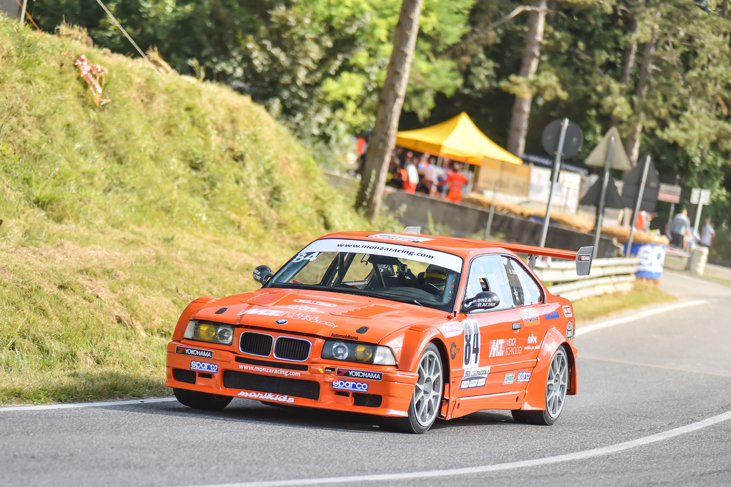
Mosca Gubbio

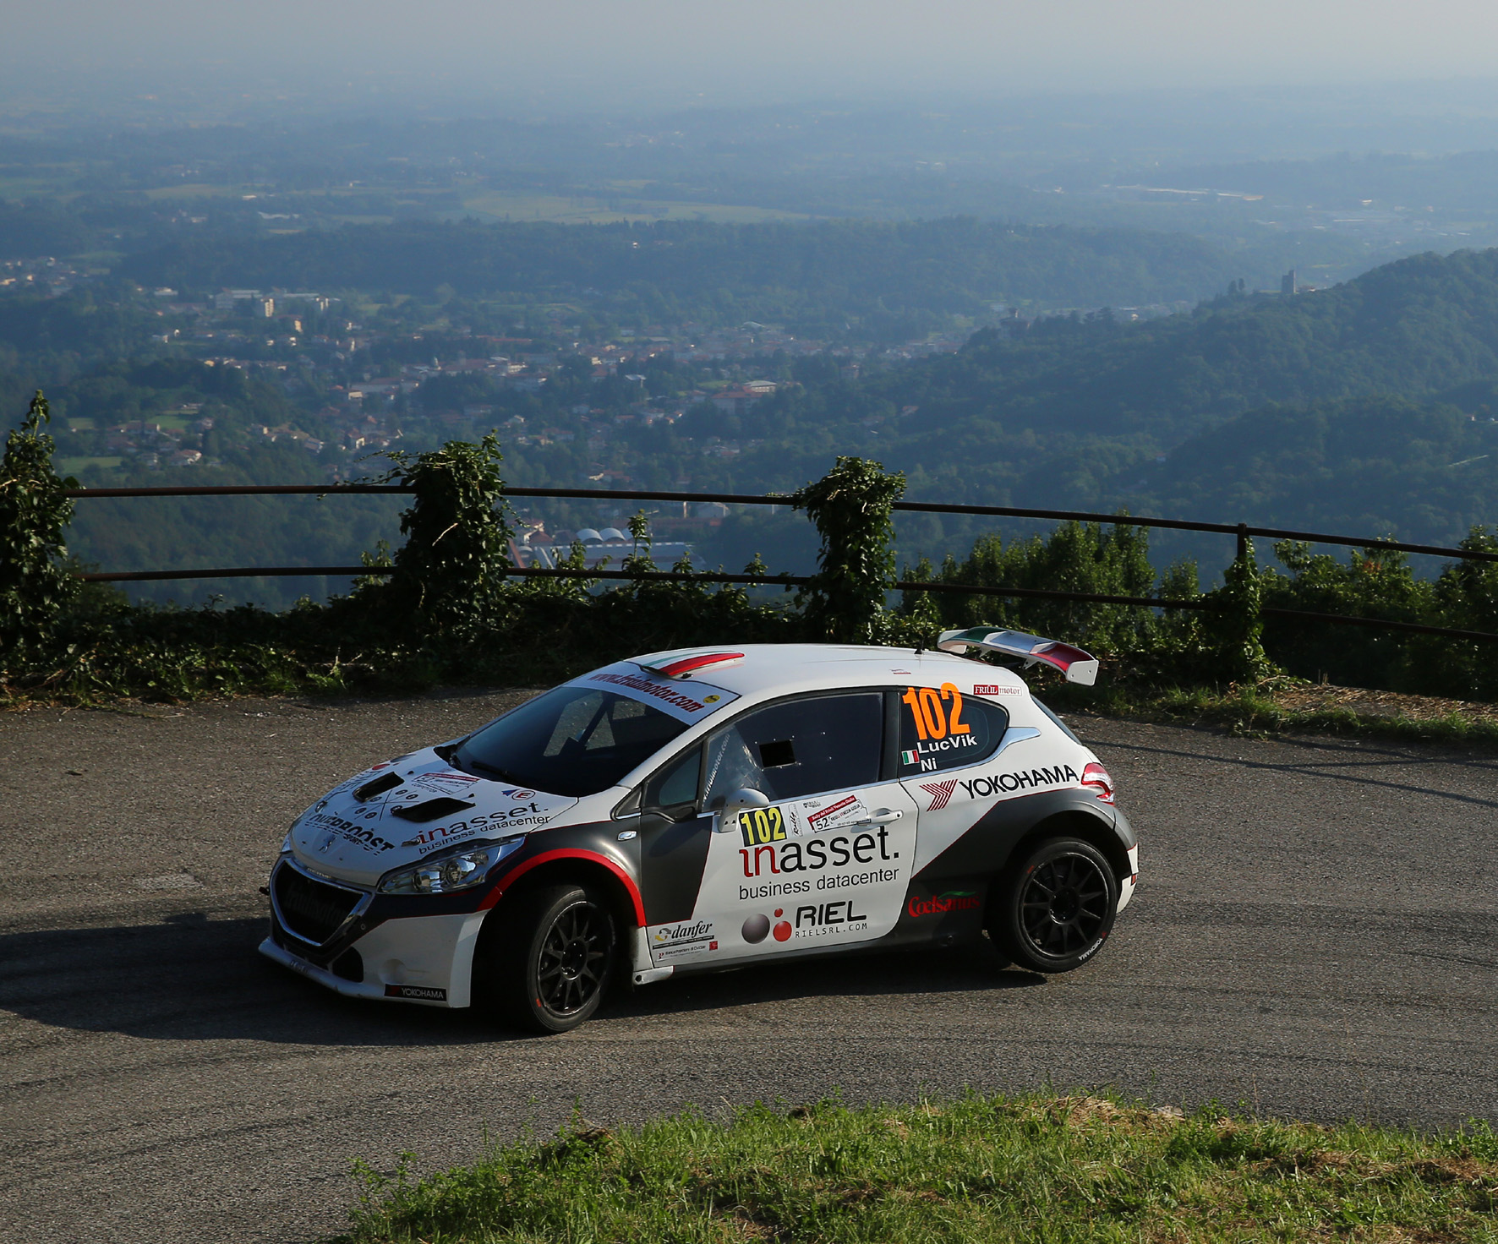
Vicario alpi Orientali

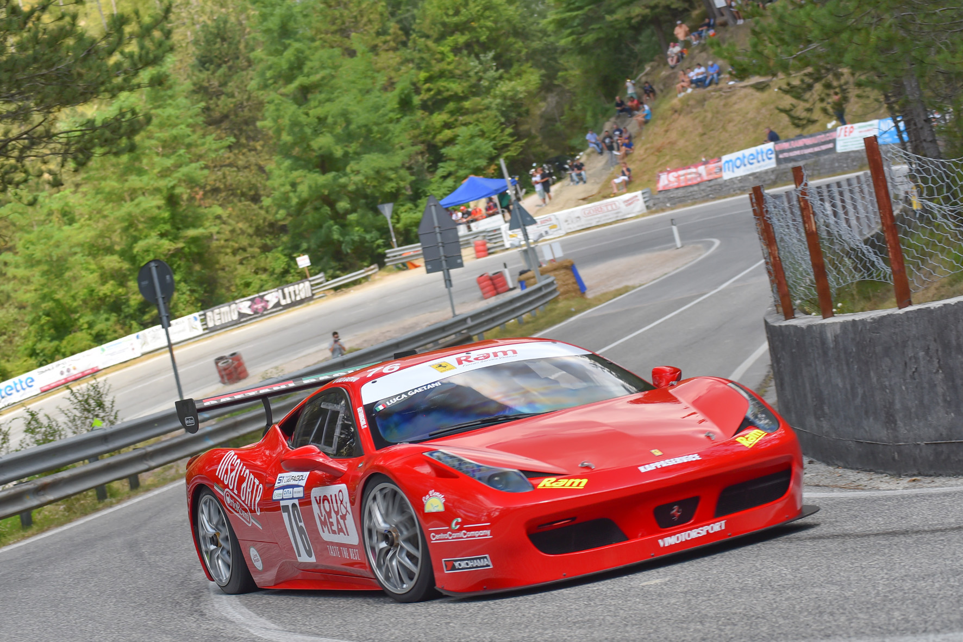
Luca Gaetani Gubbio

